WEBSITE Headline Menu - Navigation Bar
HOME
IT’S YOUR TIME TO BLOOM. 💐

Intentional travel. Proactive longevity. A journey back to yourself.
You've spent years caring for work, family, relationships, and the people around you.
Now imagine giving yourself permission to pause - to wake up by the sea, explore without rushing, savor Vietnamese cuisine, discover beautiful places, laugh with new friends, and simply enjoy being you.
Blooming Passage invites you to experience Vietnam differently - slowly, meaningfully, and with intention.
Our intimate small-group experiences bring together culture, wellness, beauty, culinary discovery, connection, and personal time - creating space to explore, recharge, and reconnect with yourself.
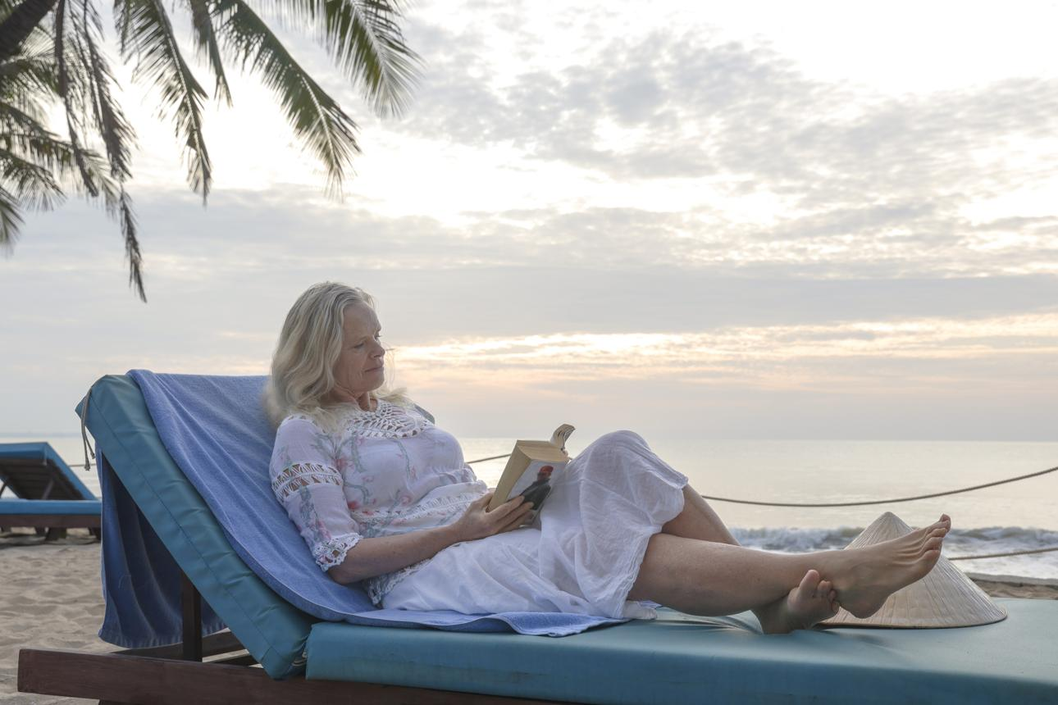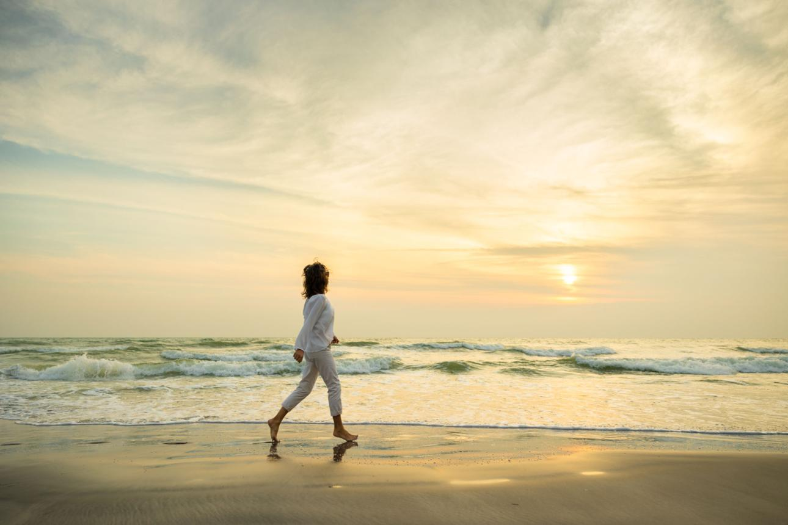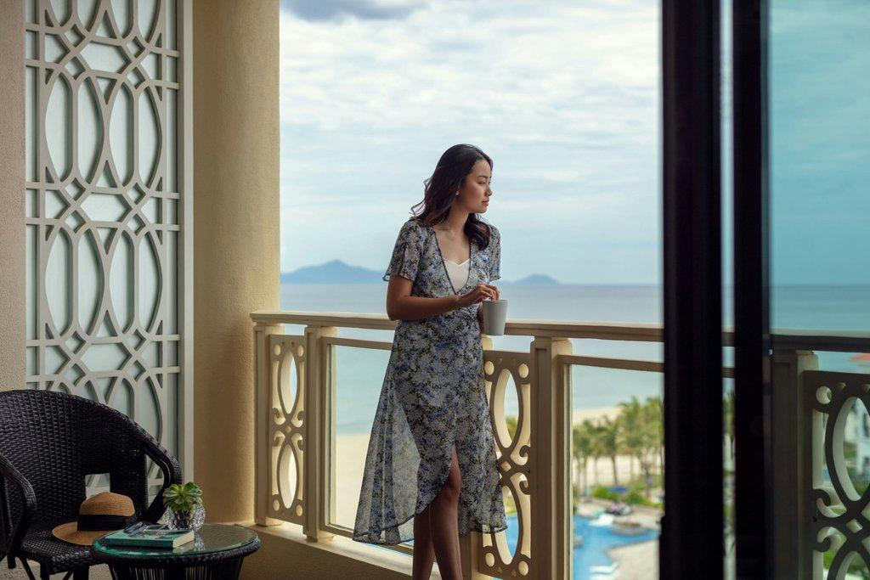
Discover the heart behind Blooming Passage? Read Our Story.
OUR STORY
Reclaiming Your Vitality.
When was the last time you felt completely heard, cared for, and informed by your doctor?
If you are like most women, navigating healthcare at home feels like an uphill battle of rushed 10-minute visits, complex patient portals, and unanswered questions. For a long time, I spent years putting everyone and everything else first - my career, my family, my daily responsibilities - while placing my own well-being on the back burner.
Then, a sudden, unexpected health scare completely stopped me in my tracks.
Realizing I needed clarity and a deep mental, emotional, and physical reset instead of endless waiting rooms, I took a leap of faith and traveled to Vietnam on my own for the first time.
That journey changed everything.
In just days, I completed a comprehensive executive physical and sat down face-to-face with providers who walked me through my scans and bloodwork line by line. For the first time, I walked away with complete peace of mind, knowing exactly where I stood health-wise and how to naturally support my body moving forward.
After sharing my experience with my closest girlfriends, their encouragement gave me the courage to create Blooming Passage.
I created Blooming Passage for women who are ready to make space for themselves - to pause, reconnect, and experience something meaningful at their own pace.
If you’re in a season of life where you’re ready to put yourself back on the list, I hope you’ll join me in Central Vietnam.
Come curious. Come open. Come as you are.
Our Philosophy: Inner Vitality Meets Outer Confidence
We believe that growing old gracefully isn’t about avoiding age; it is about taking full control of your vitality:
- Uncompromised Medical Insight: Access world-class international health diagnostics and specialist consultations at a fraction of Western out-of-pocket costs, without administrative headaches.
- Holistic Self-Care: Pair inner metabolic clarity with outer confidence - welcoming aesthetic and dental enhancements that honor how you feel when you look in the mirror.
- A Supportive Sisterhood & Safety Focus: Travel with absolute peace of mind in a boutique, secure setting designed exclusively for women, featuring personal hosts on the ground and seamless, white-glove logistics every step of the way.
There’s no perfect way to arrive at this season of life - and no perfect way to experience Blooming Passage.
Just come ready to explore, to slow down, to try something new, and to see what you might discover along the way.
Come curious. Come open. Come as you are.
THE FOUR PILLARS
These four guiding principles are woven into every Blooming Passage journey.
INTENTION
Make space for yourself.
Give yourself permission to step away from the demands of everyday life and pay attention to what you need.
LONGEVITY
Become more informed about your health.
Explore proactive wellness and personal health awareness through thoughtfully selected experiences and optional health services.
DISCOVERY
Go beyond sightseeing.
Experience the people, food, craftsmanship, landscapes, and traditions that make Central Vietnam so special.
CONNECTION
Travel alongside women who understand this season of life.
Small groups. Shared experiences. Meaningful conversations. New friendships.
Connection that continues long after the journey ends.
Culinary Discovery

Come Hungry. Leave Inspired.

Food is one of the best ways to experience a culture. Taste your way through Central Vietnam - from local markets and street food to hands-on cooking, tea ceremonies, and thoughtfully curated meals.
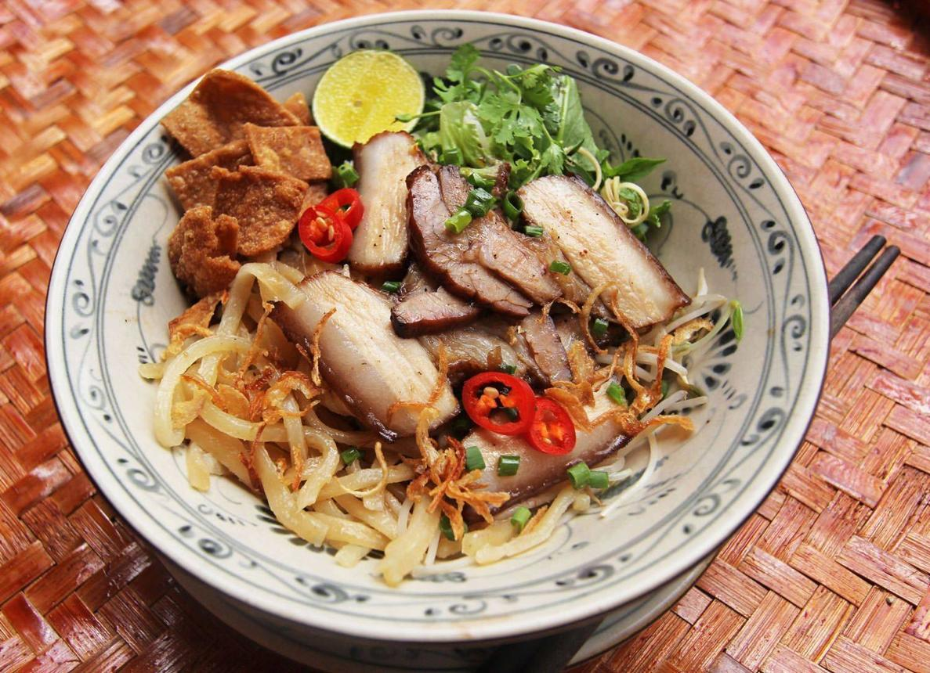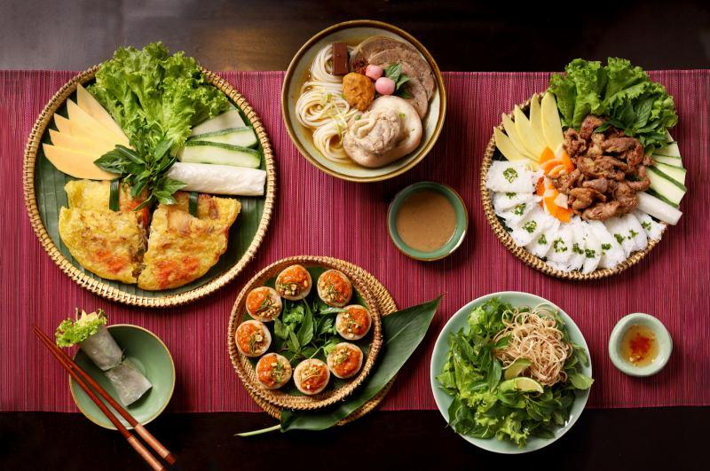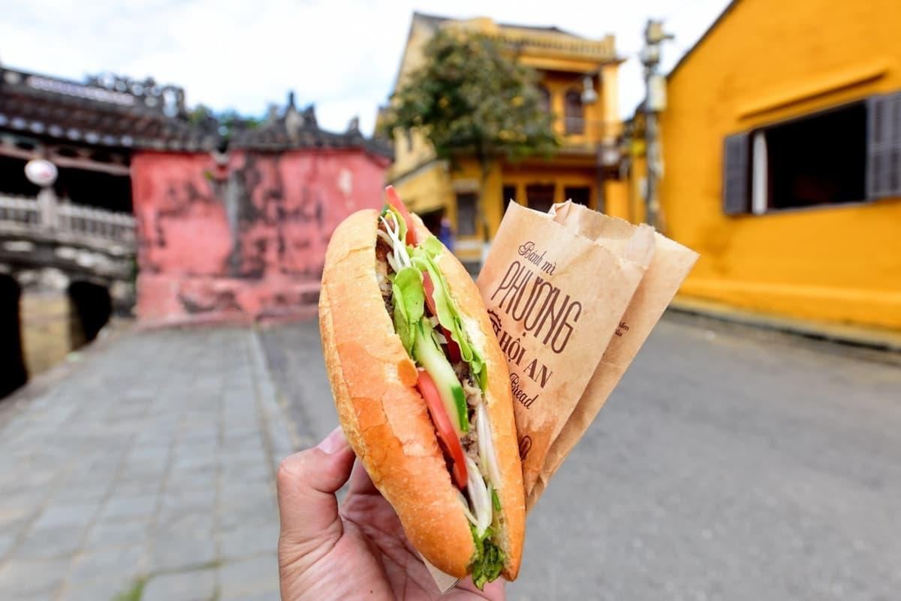
Beyond the Tourist Trail

Meet the Makers
Go beyond sightseeing. Meet local artisans, explore gardens and countryside, discover traditional crafts, and experience the stories and traditions that make Central Vietnam unique.
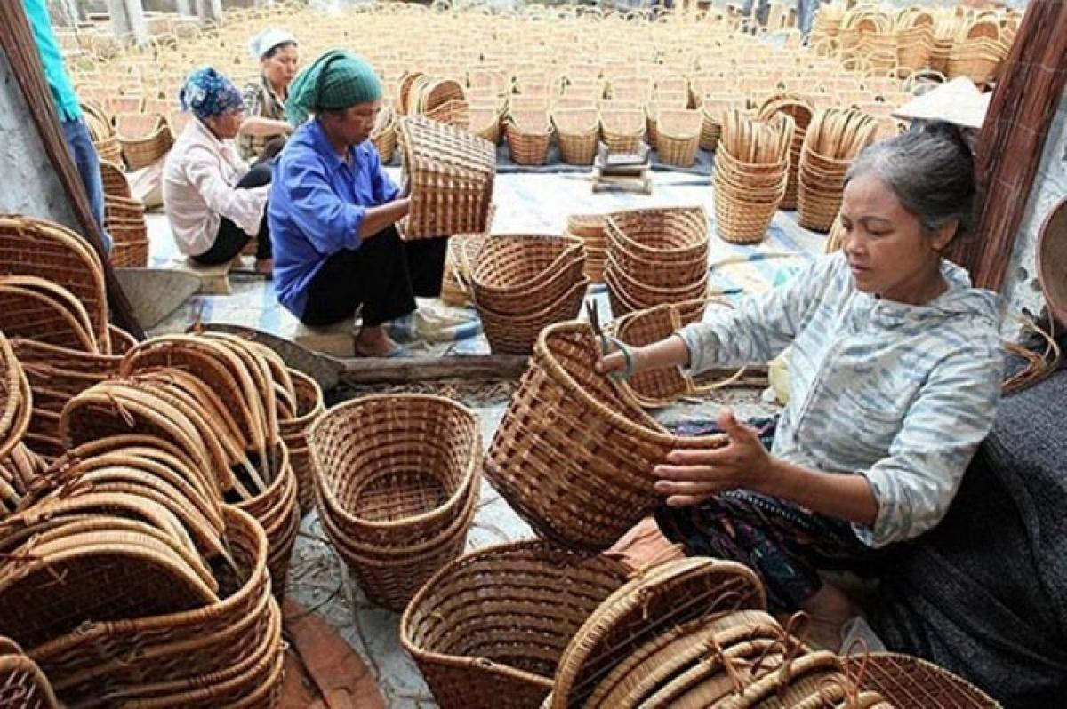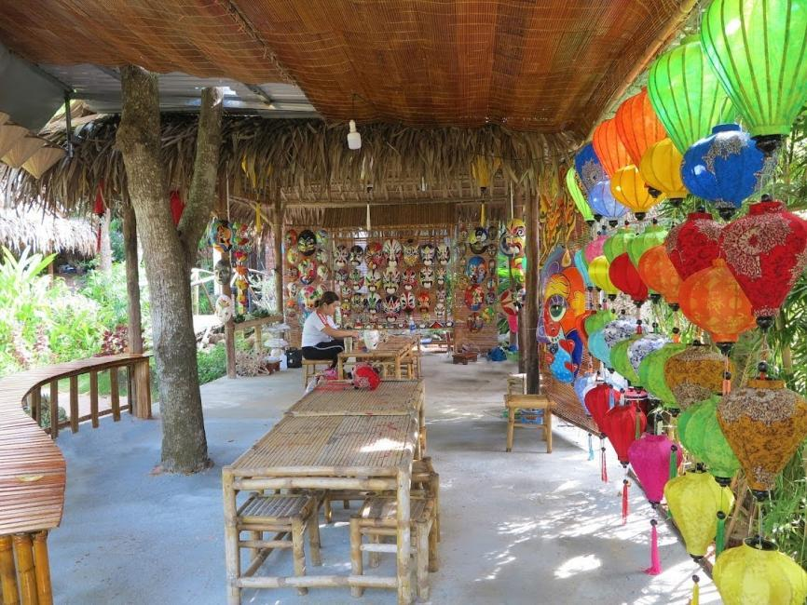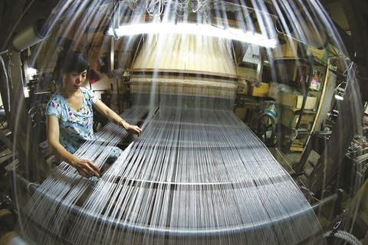
Vietnam After Dark

When the Sun Goes Down, Vietnam Comes Alive.
Experience Central Vietnam after dark with a private Vespa food adventure, local flavors, night markets, and the energy of the city - shared with your fellow travelers.
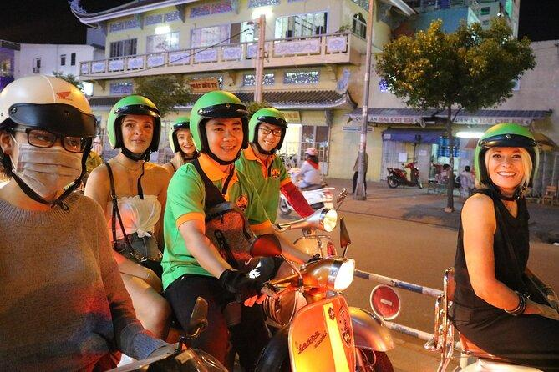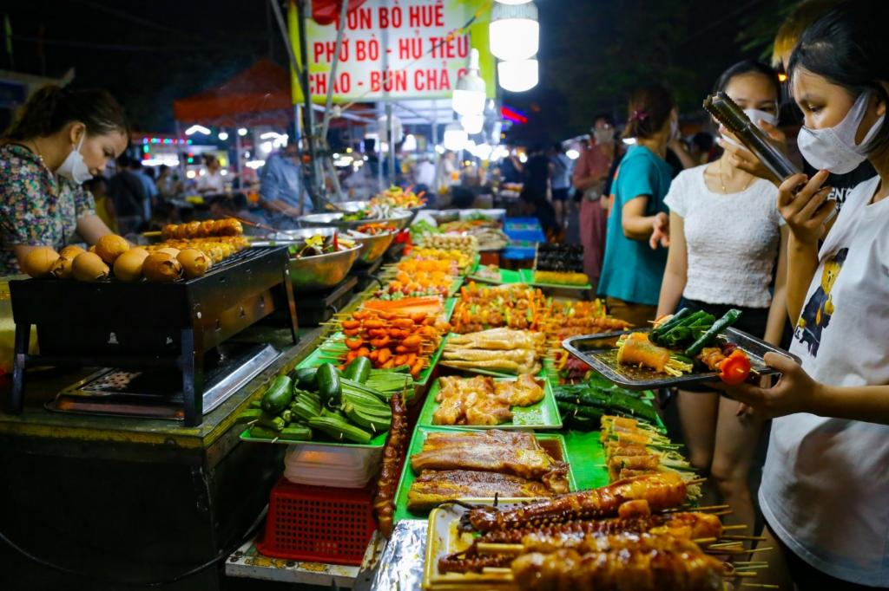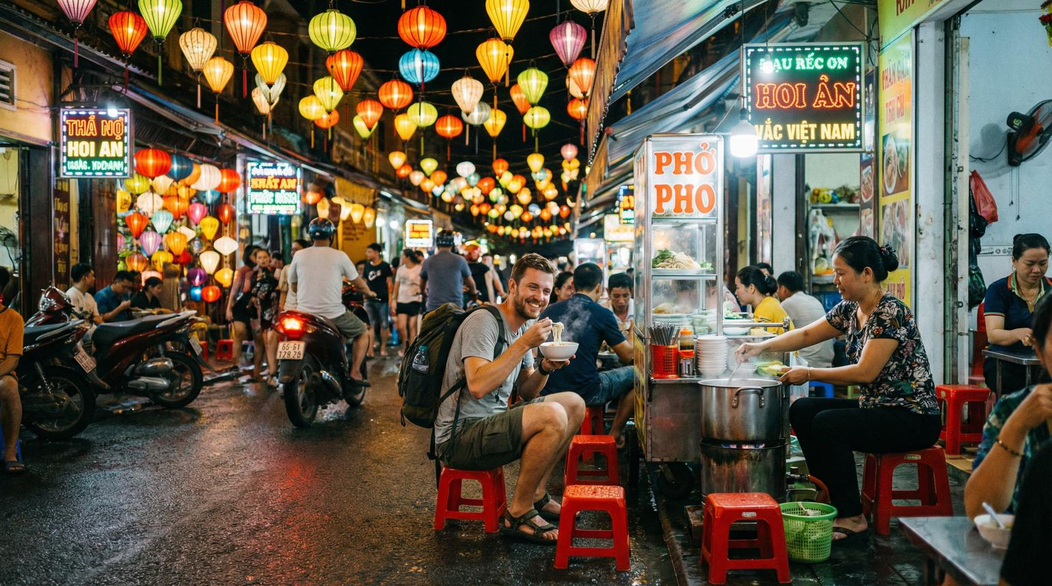
Your Own Passage of Self-Care

Travel Beautifully. Care for Yourself Deeply.
Make time for yourself with thoughtfully selected experiences such as facials, massage, beauty and personal care. Or simply slow down, walk along the beach, and enjoy doing nothing at all.
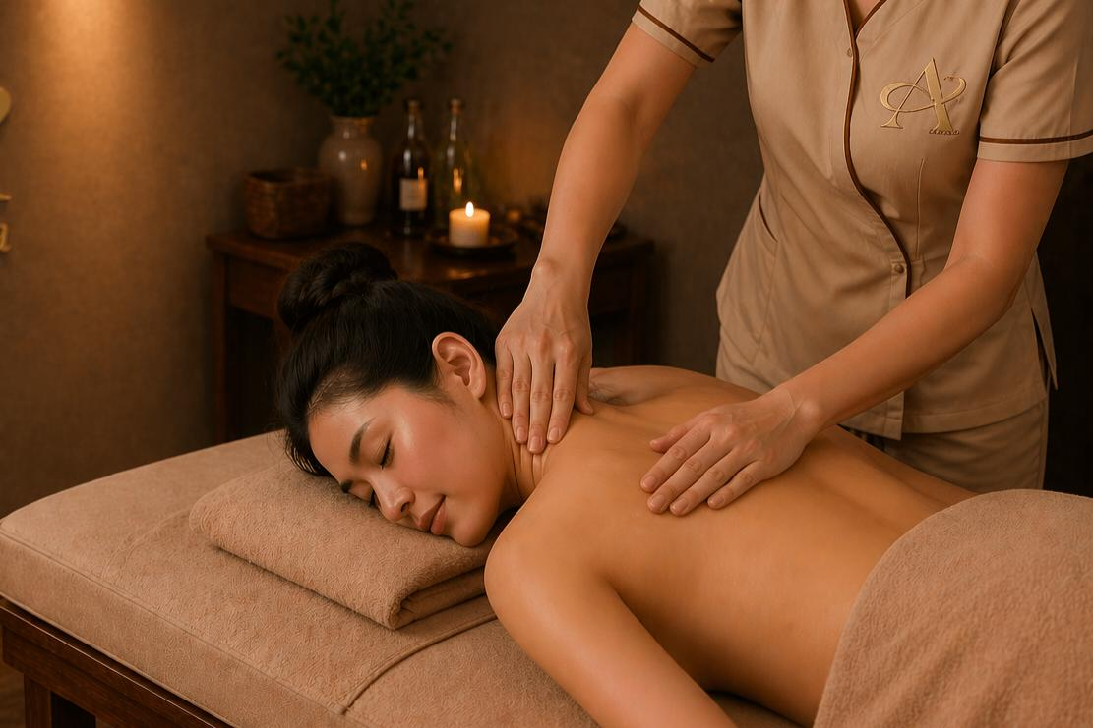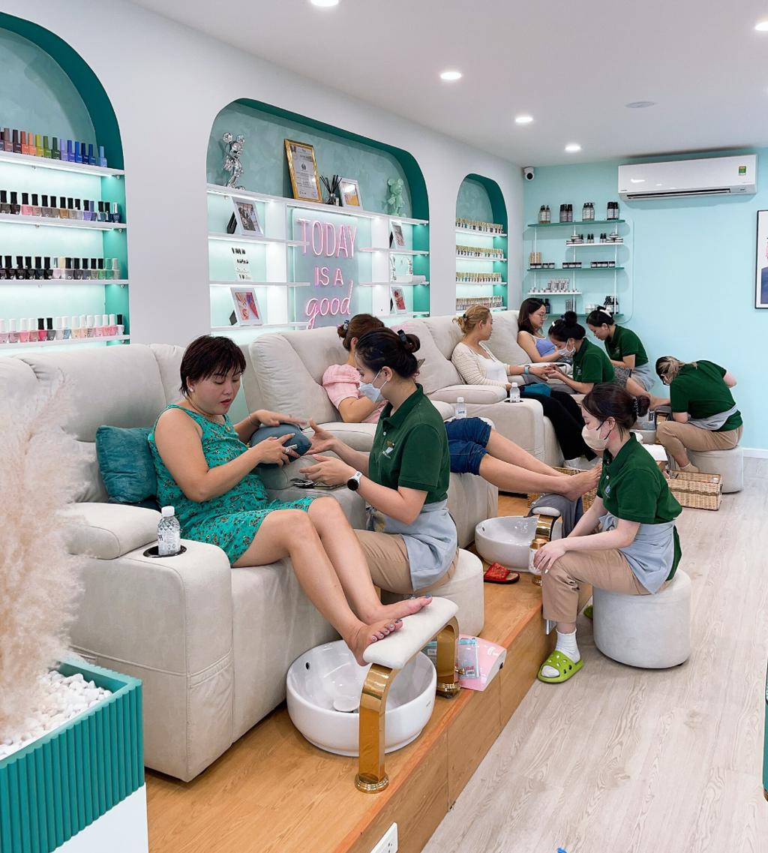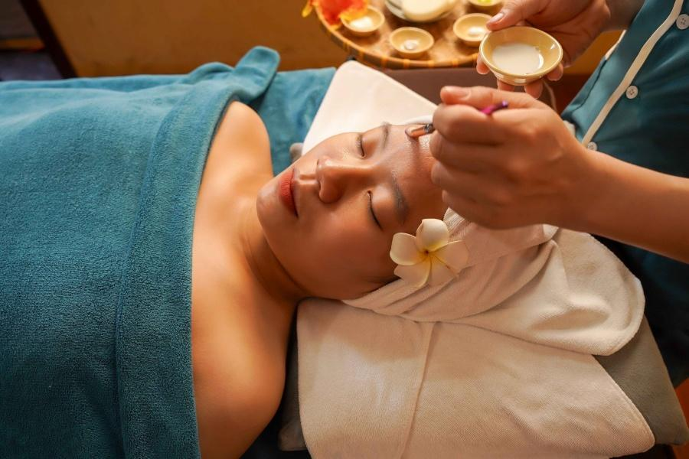

Proactive Health & Longevity

Know More. Care Earlier. Live Intentionally.
If you choose, add thoughtfully selected health and wellness experiences, from comprehensive health assessments and dental care to skin consultations and preventive screenings.
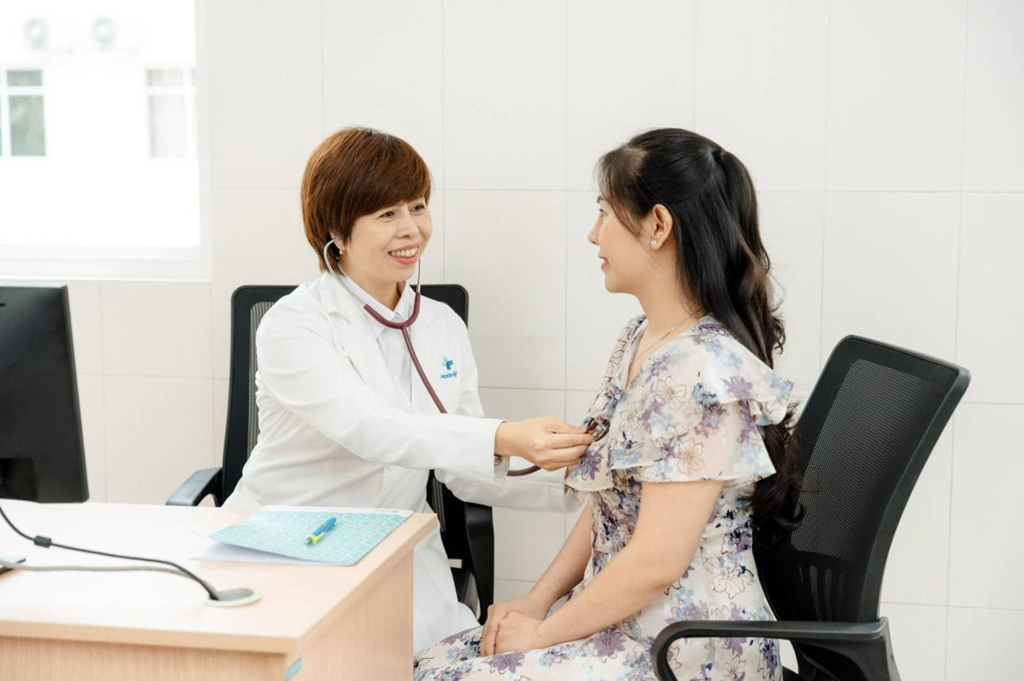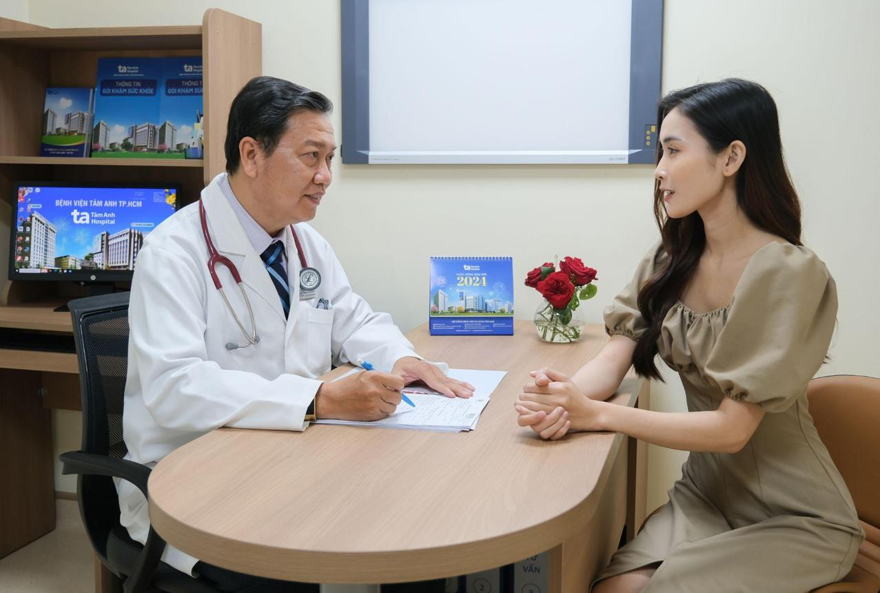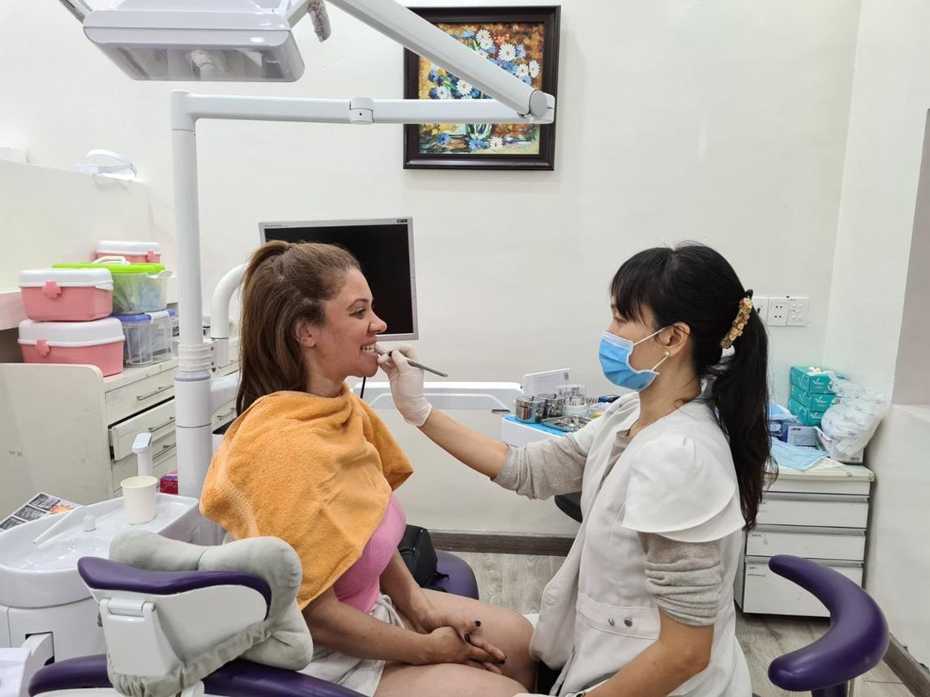
Your Beachfront Sanctuary
Your Time. Your Pace. Your Sanctuary.

After a day of exploring, return to your peaceful beachfront sanctuary.

Wake to the sound of the ocean. Savor an unhurried breakfast, take a morning walk, enjoy a massage, watch the sunset - or simply do nothing at all.

There’s no prize for rushing through your vacation. This is your time to slow down, breathe, and simply be.
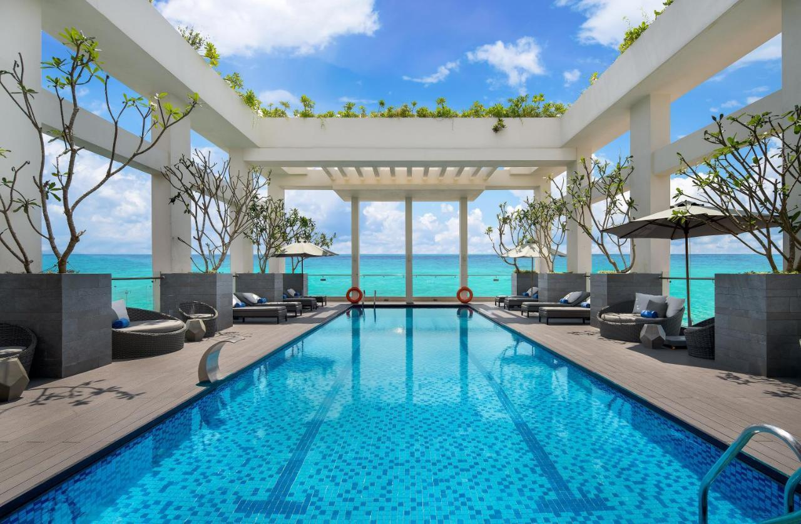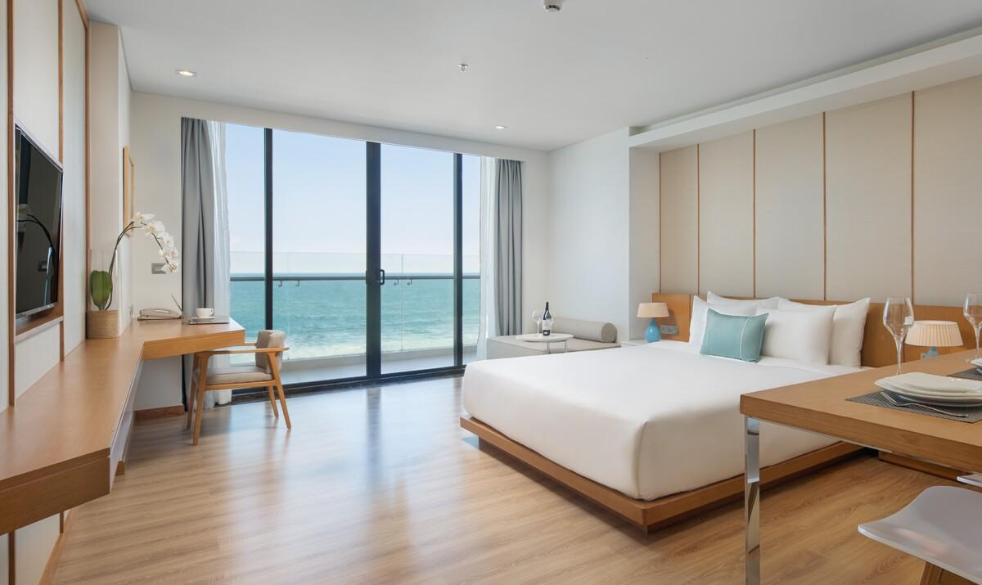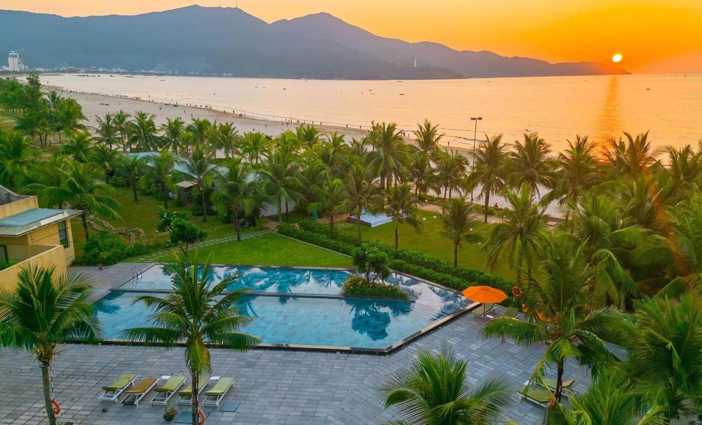
WHY CENTRAL VIETNAM?
We chose Central Vietnam because it brings so much together in one beautiful region.
From beaches of Da Nang to lantern-lit streets of Hoi An and the timeless beauty of Hue, you’ll experience a wonderful balance of coastal calm, culture, history, food, craftsmanship, and everyday Vietnamese life.
It’s a place where you can begin your morning by the sea, spend an afternoon discovering centuries-old traditions, enjoy an intimate meal, and end the day with a massage or quiet moment to yourself.
Central Vietnam allows us to create journeys that feel rich and meaningful without feeling rushed.
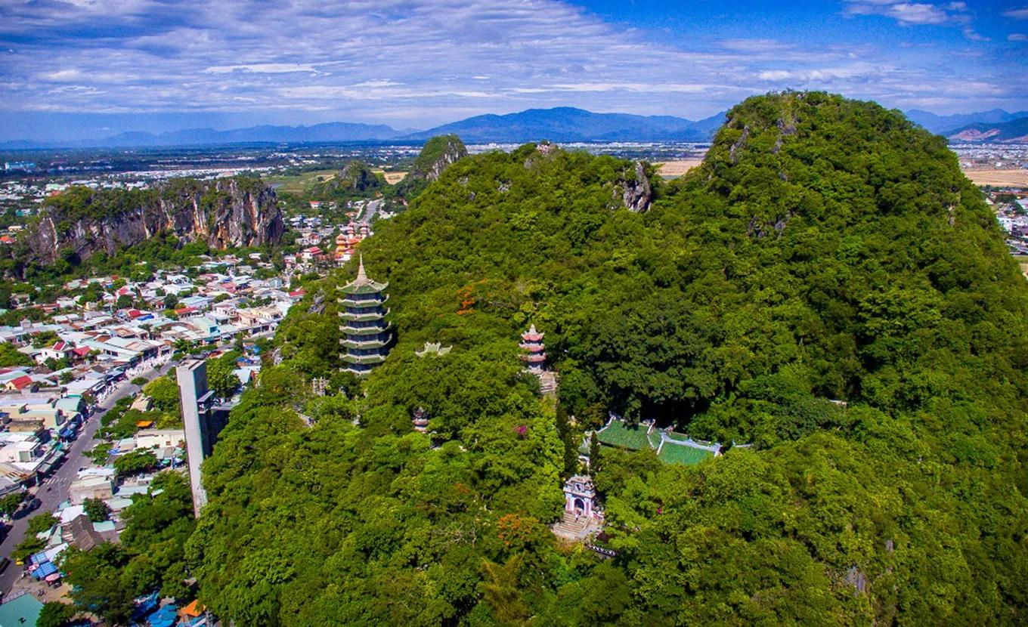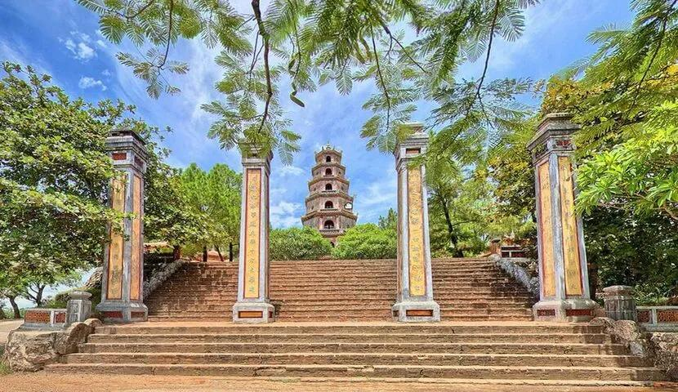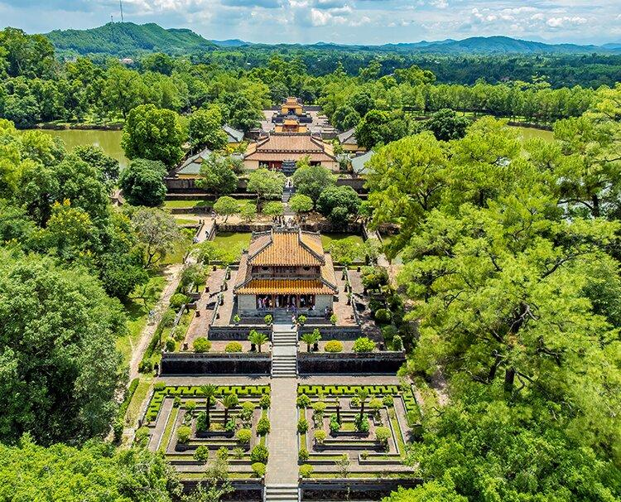
Three Destinations. One Beautiful Passage.
DA NANG
Where your journey begins.
Ocean air. Long beaches. Vietnamese cuisine. Beautiful resorts. Sunset walks. Time to simply be.
Your beachfront home base gives you space to settle in, slow down, and enjoy the rhythm of the coast before beginning your discoveries throughout Central Vietnam.
Slow mornings. Ocean breezes. Restorative evenings.
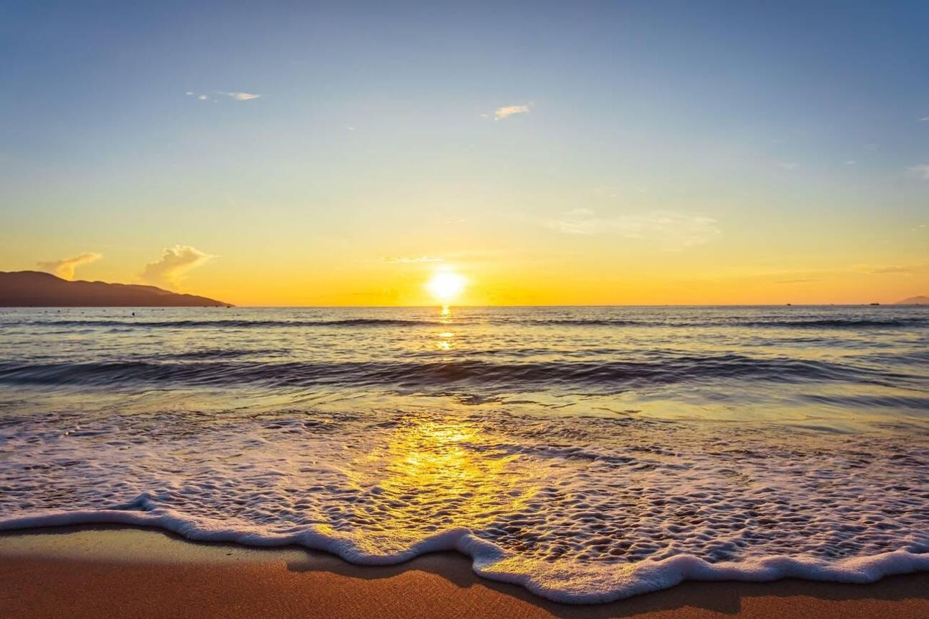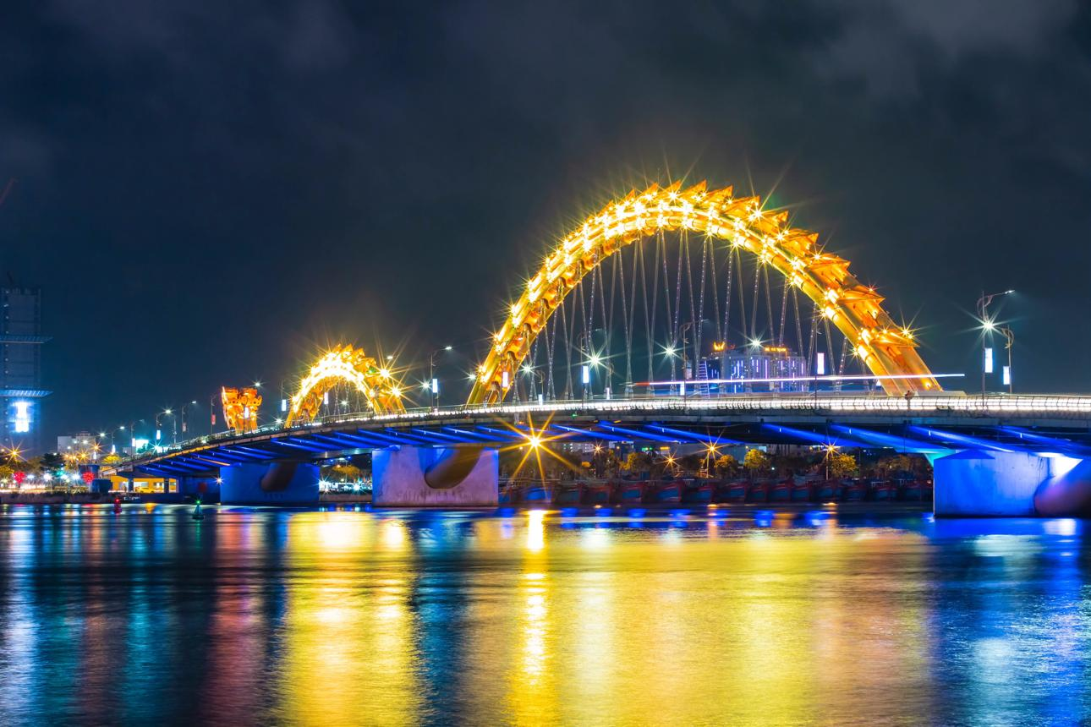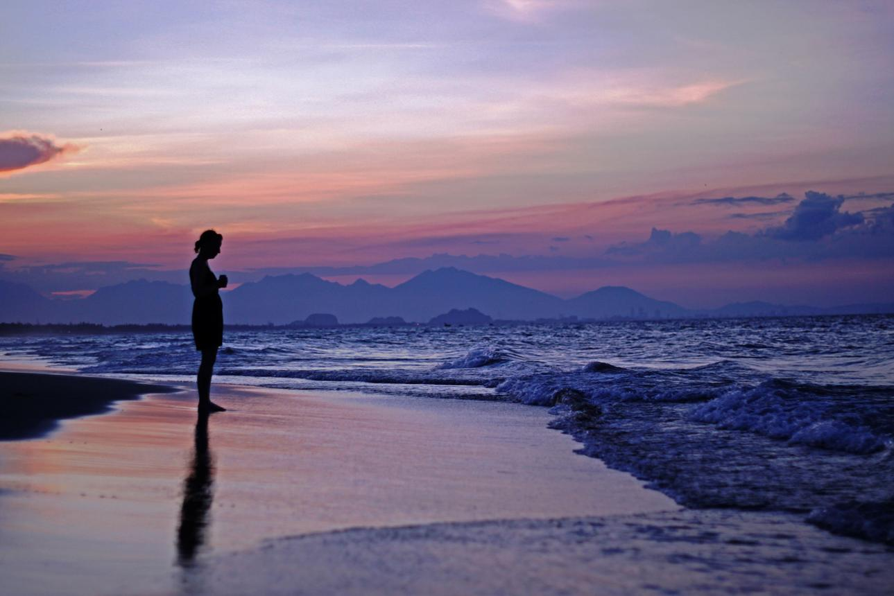
HOI AN
Where history comes alive.
Lantern-lit evenings. Ancient streets. River boats. Tailored clothing. Local artisans. Countryside paths. Vietnamese cooking.
Hoi An invites you to wander, discover, and experience a slower, more intimate side of Vietnam.
Your Hoi An experience might include:
- A leisurely cyclo ride through the Ancient Town
- Lantern-lit evenings along the Thu Bon River
- A peaceful ride in a coconut basket boat
- Visiting a local tailor for your custom-made clothing
- Vietnamese cooking experiences
- Learning to make noodles or rice paper
- Visiting artisan communities
- Discovering traditional silk weaving
- Exploring local markets and boutiques
- Cycling through countryside and rice paddies
- Sampling Vietnamese specialties
And rather than racing from attraction to attraction, you'll have time to look, taste, create, and enjoy.
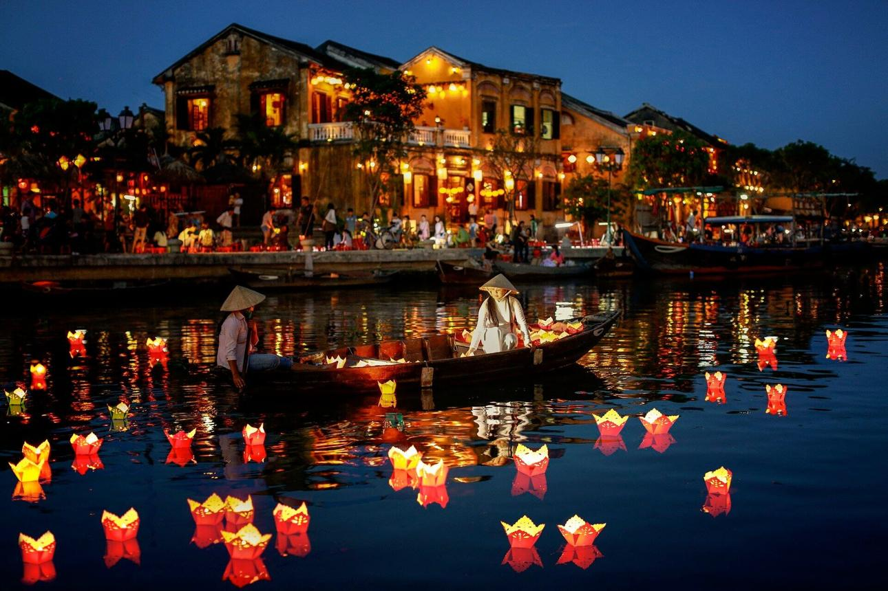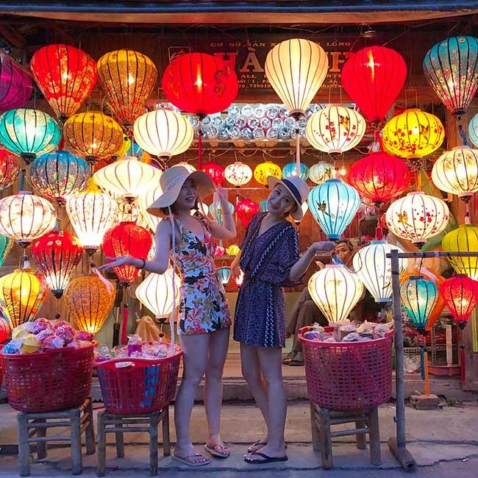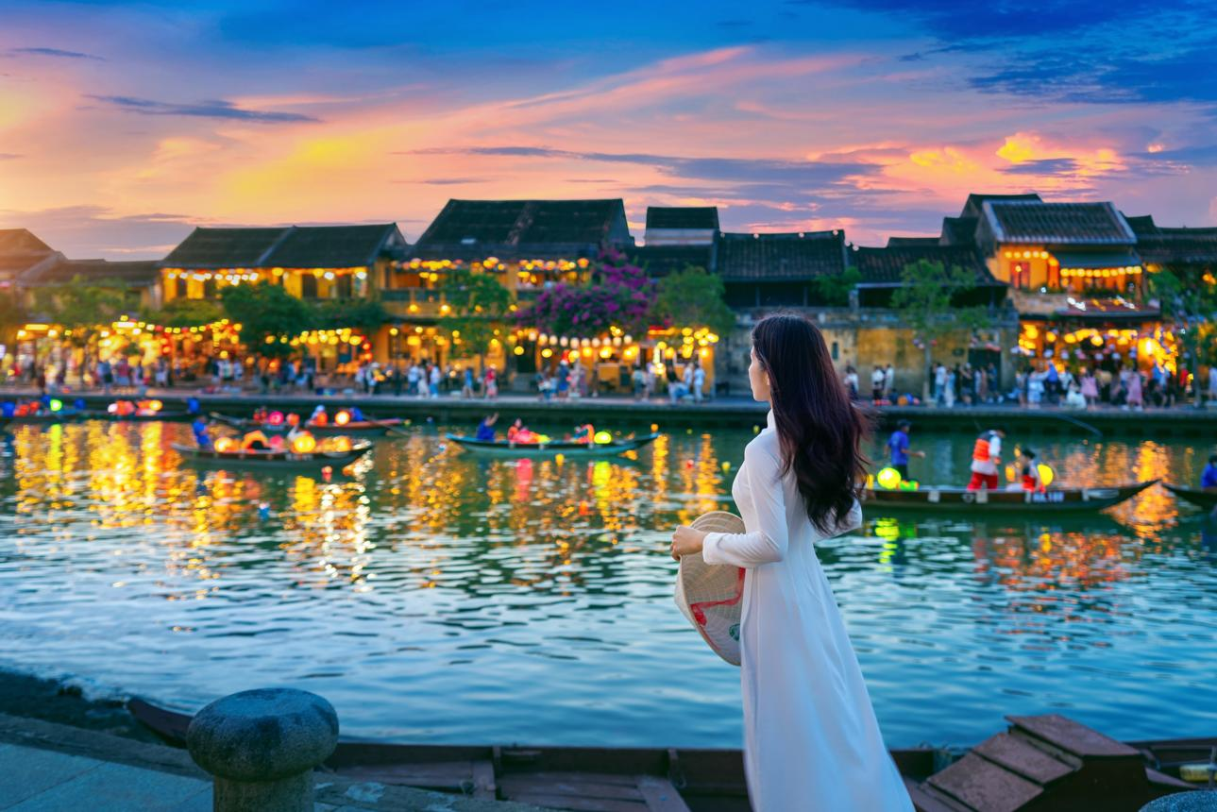
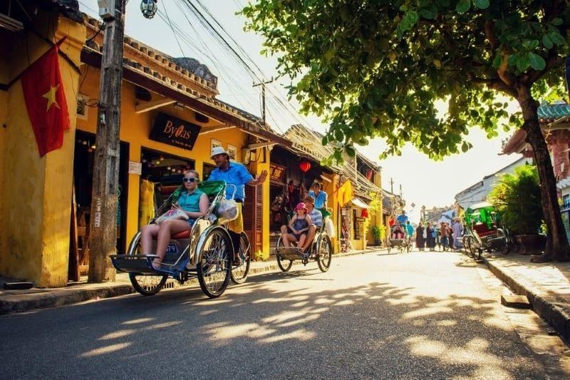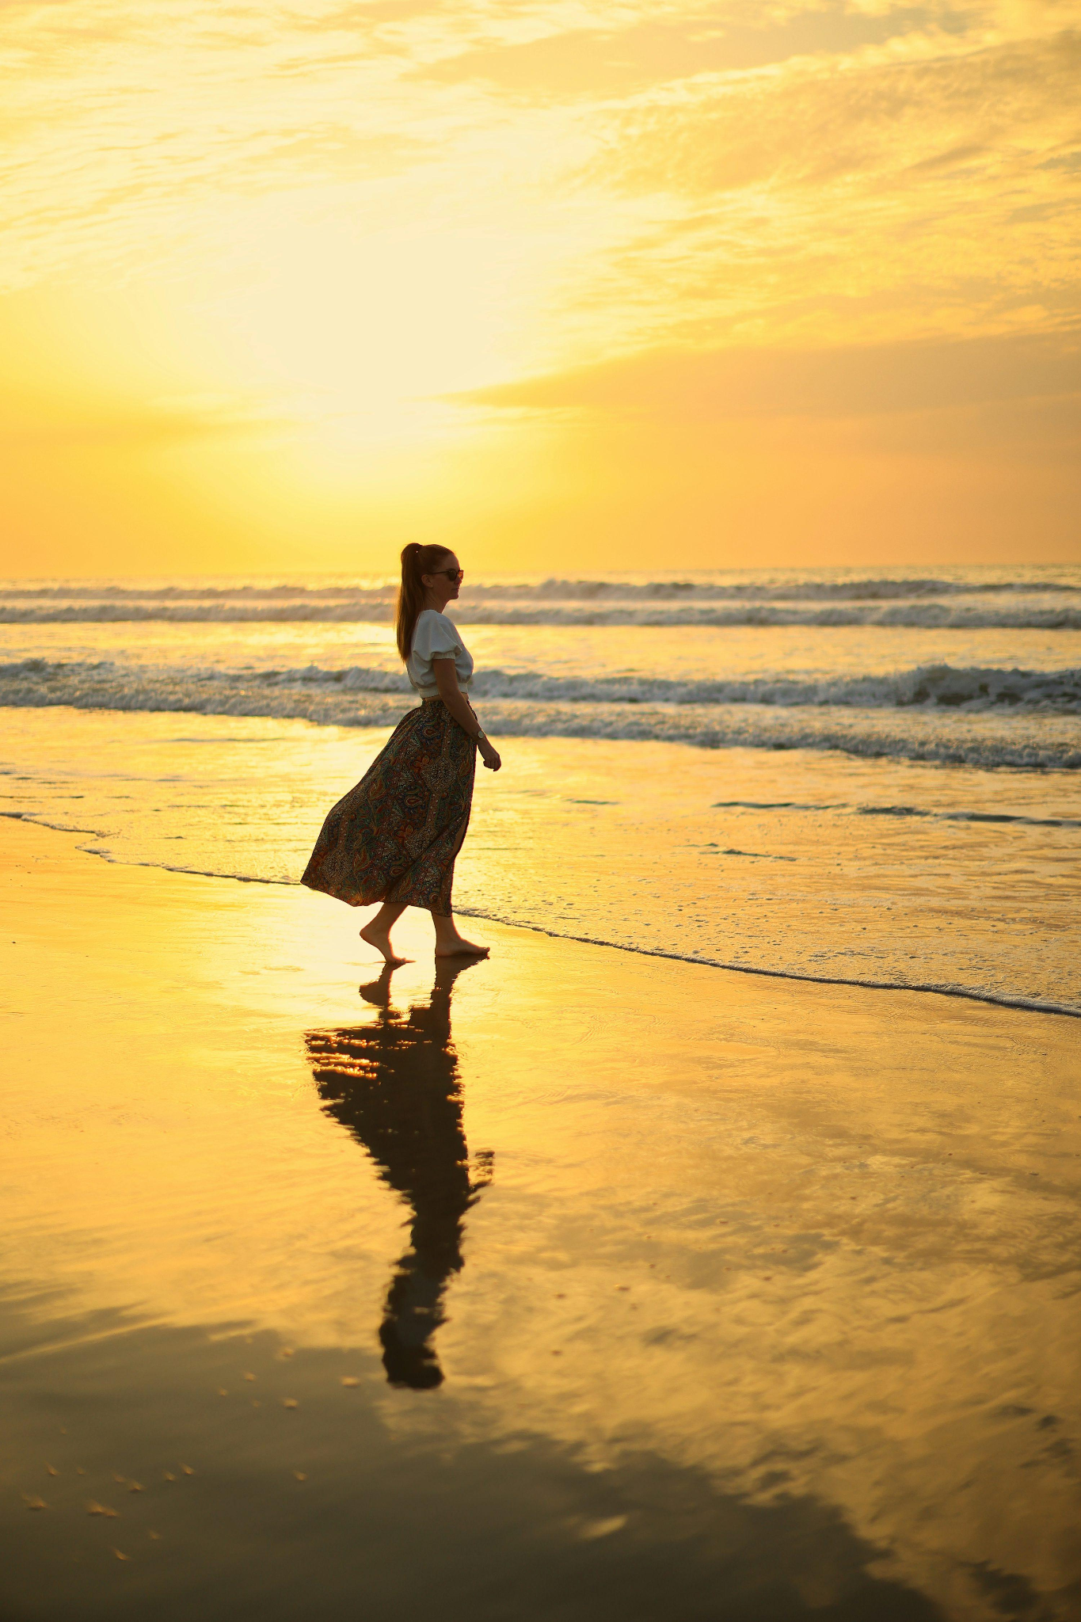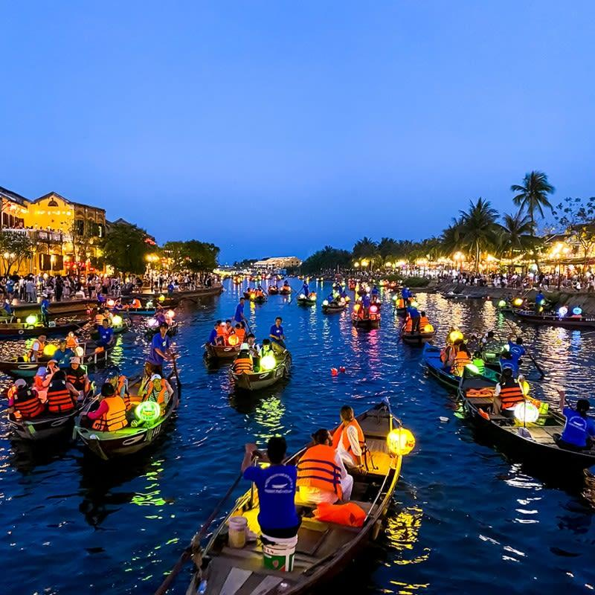
HUE
Where history meets tranquility.
Discover Vietnam’s former imperial capital through:
The Imperial City * Thien Mu Pagoda * Perfume River * Traditional garden houses * Royal dining experience
Hue isn’t simply another sightseeing stop.
It’s an opportunity to slow down and experience another layer of Vietnam’s history, culture, and timeless beauty.
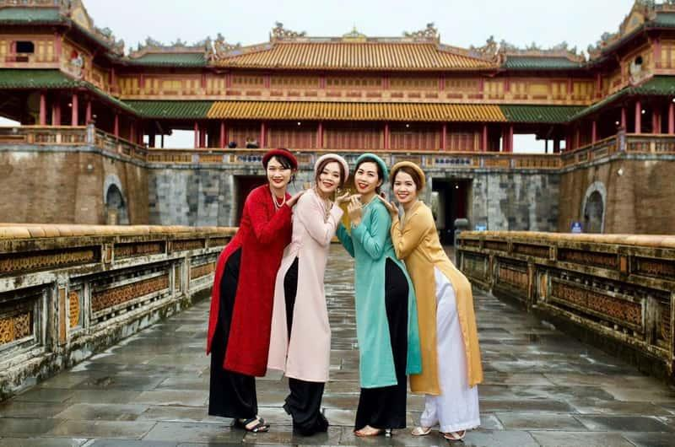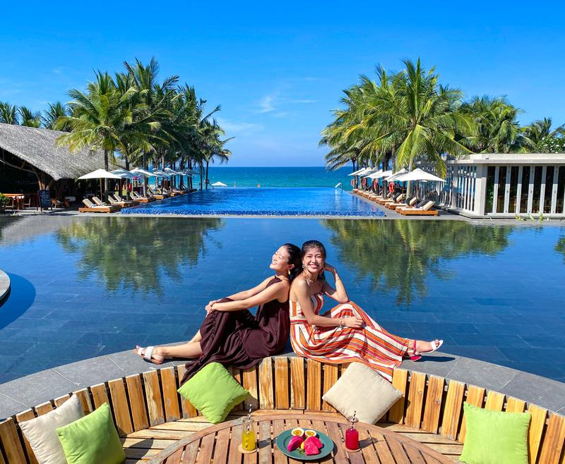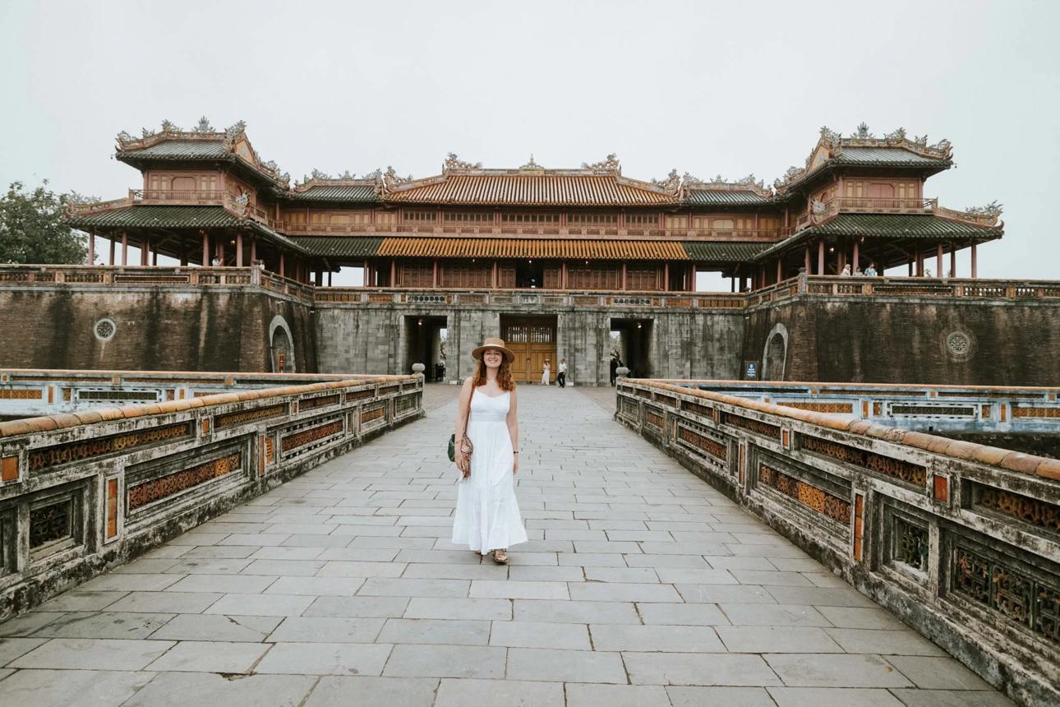

SIGNATURE JOURNEYS

Travel with intention. Come home feeling renewed.
Blooming Passage is for women who want more than a vacation. It’s an invitation to slow down, reconnect with yourself, and experience Vietnam in a way that feels meaningful, personal, and unhurried.
Imagine waking up by the sea, wandering through historic streets, sharing a meal with new friends, discovering local artisans, savoring Vietnamese flavors, and making space for the things that often get pushed aside—your wellbeing, your curiosity, your beauty, and simply enjoying life.
Our journeys are intentionally small, thoughtfully paced, and hosted with care. With approximately 5–10 women per group, you’ll have a beautiful beachfront home base in Da Nang and curated experiences throughout Da Nang, Hoi An, and Hue.
There is time to wander.
Time to savor.
Time to rest.
Time to connect.
And time to simply be.

MORE THAN A VACATION
Each journey brings together:
Travel + Culture + Culinary Discovery + Wellness + Beauty + Proactive Health + Connection
All woven into an intimate small-group experience designed to feel effortless, personal, and restorative.

FOUR SIGNATURE EXPERIENCES
Every Blooming Passage journey is thoughtfully woven around four experiences that capture the heart of Central Vietnam.

HERITAGE
Walk through centuries of Vietnamese history and culture. Discover Hoi An’s timeless beauty, explore Hue’s rich heritage, and experience the traditions that make Central Vietnam so special.

ARTISAN & ORCHARD
Step beyond the usual tourist experience. Meet local artisans, visit gardens and countryside communities, and discover the creativity and everyday beauty of Vietnam.

CULINARY PASSPORT

Come Hungry. Leave Inspired.
Taste your way through Central Vietnam—from local markets and street food to hands-on cooking, tea experiences, and memorable meals.
Learn. Taste. Share. Enjoy.

SANCTUARY & BEAUTY
Slow down and take care of yourself. Enjoy spa treatments, skincare, massage, beauty experiences, and unhurried time to relax by the sea.
Because sometimes the most meaningful part of a journey is simply having the space to breathe.
Rest. Renew. Restore.
WELLNESS & LONGEVITY

Make Your Journey Your Own
Your Blooming Passage journey can be as restorative as you want it to be. Alongside the wellness experiences included in your itinerary, you can choose additional medical, dental, beauty, and wellness enhancements that feel right for you.
Whether you’d like to add a health check-up, enjoy a little more time for self-care, or extend your stay for additional services, rest, or follow-up appointments, we’ll help you create a journey that feels personal and unrushed.

Optional Experiences May Include
- Comprehensive health check-ups
- Dental examinations and cleanings
- Dermatology and skincare consultations
- Non-invasive beauty treatments
- Hair and nail services
- Additional spa and wellness treatments
These experiences are here to complement your journey - not define it. You’ll have the freedom to choose what feels meaningful to you, while still leaving plenty of room to explore, relax, and enjoy Vietnam.
Blooming Passage coordinates all travel logistics, concierge support, and third-party scheduling. Medical, dental, and aesthetic consultations are rendered by independent, licensed professionals.
SMALL GROUP DIFFERENCE
We keep our groups intentionally small - typically 5-10 women.
Small groups create something special. There’s room to get to know one another, share a meal without feeling like a crowd, linger a little longer when something catches your interest, and enjoy experiences that feel personal rather than packaged.
You’ll travel alongside women with different stories, perspectives, and life experiences - creating a relaxed atmosphere where it’s easy to connect, laugh, linger, and simply enjoy being together.
No giant tour buses.
No racing from one attraction to the next.
No feeling like just another face in the crowd.
Instead, you’ll experience:
Thoughtful pacing. Personal attention. Genuine connection. Shared experiences.
You’ll have the companionship of a group, without feeling like you’re part of a crowd - and enough breathing room to enjoy moments of quiet time on your own.
You Explore and Enjoy the Journey. We Take Care of the Details.
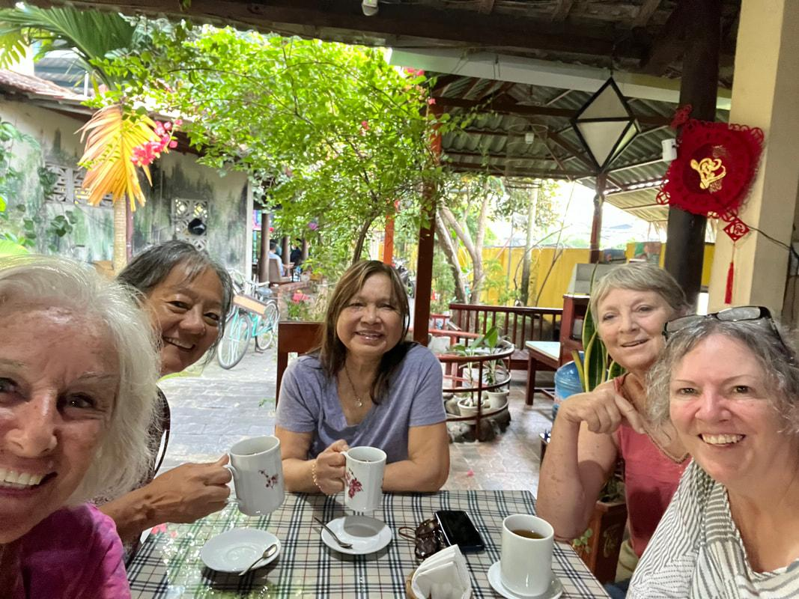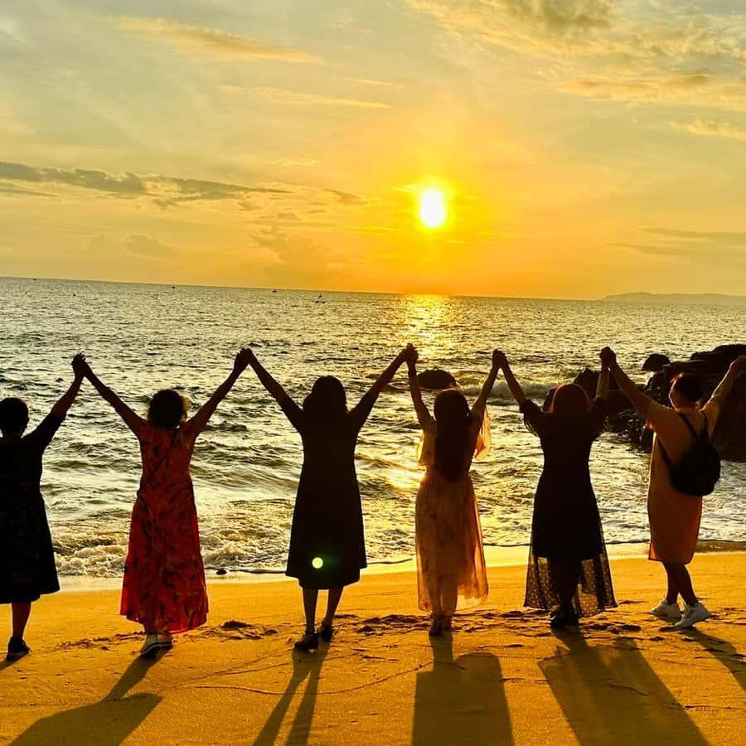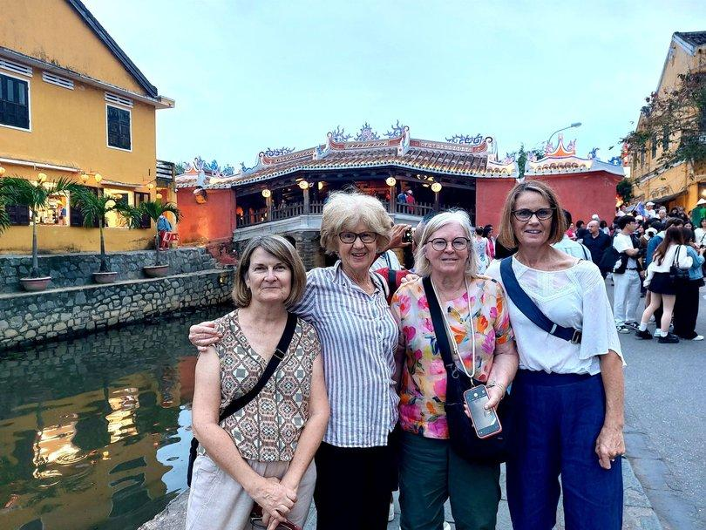
WHAT’S INCLUDED
From the moment you arrive in Da Nang, Blooming Passage is designed to make your journey feel comfortable, supported, and easy.
Every Blooming Passage journey includes the thoughtful essentials that make your experience seamless from beginning to end:
- Private airport arrival and departure transfers
- A warm welcome and personal orientation
- Comfortable private transportation throughout the journey
- English-speaking local guide and Blooming Passage host/coordinator
- Carefully selected boutique accommodations
- Daily Breakfast
- Curated cultural and local experiences
- Hoi An and Hue experiences
- Culinary and artisan experiences
- Thoughtfully planned meals and dining experiences
- Local cultural guidance
- Assistance navigating appointments
And, of course, the little things matter - the details, introductions, timing, and personal touches that help you feel cared for rather than simply guided.

HOW IT WORKS

1. Select Your Passage
Explore our 7-day, 10-day and 14-day journeys and choose the experience that feels right for you.
2. Find Your Dates
Choose your departure date and reserve your place with a deposit.
3. We Take Care of the Details
From airport pickup and accommodations to transportation, curated experiences, and thoughtful coordination, we handle the details so you can focus on enjoying your time in Vietnam.

4. Make It Your Own
Add optional wellness, health, beauty, or personal-care services or extend your stay if you'd like more time to rest, explore, or attend appointments.

Arrive. Exhale. Bloom.
Come ready to experience Central Vietnam at a relaxed pace, meet new people, discover something beautiful, and make time for yourself.
You choose the journey. We take care of the rest.
WHAT YOU CAN EXPECT
With approximately 5–10 women per group, you'll experience Vietnam at a comfortable, thoughtful pace - with a beautiful beachfront home base in Da Nang and curated journeys through Hoi An and Hue.
Every Blooming Passage journey is thoughtfully curated around four signature experiences:

HERITAGE
Walk through centuries of Vietnamese history and culture. Discover Hoi An's timeless beauty, explore Hue's heritage, and experience the traditions that make Central Vietnam so special.

ARTISAN & ORCHARD
Step beyond the usual tourist experience. Meet local artisans, visit gardens and countryside communities, and discover the creativity and everyday beauty of Vietnam.

CULINARY PASSPORT

Come Hungry. Leave Inspired.
Food is one of the best ways to experience a culture.
Taste your way through Central Vietnam—from local markets and street food to hands-on cooking, tea ceremonies, and memorable meals.
Learn. Taste. Share. Enjoy.

SANCTUARY & BEAUTY
Slow down and take care of yourself. Enjoy spa treatments, skincare, massage, beauty experiences, and time to simply relax by the sea.
CHOOSE YOUR EXPERIENCE
🌿 7-day - Curated Essence
Da Nang * Hoi An * Wellness * Culinary Experiences
A beautiful introduction to Central Vietnam.
A thoughtfully curated escape that brings together culture, culinary discovery, wellness, and connection - with plenty of time to breathe, slow down, and simply enjoy being somewhere new.
Come for the reset. Leave with something more.

🌿 10-Day - Balanced Journey
Da Nang • Hoi An • Hue • Culture • Culinary • Wellness
More time to explore. More time to restore.
Settle into the rhythm of Central Vietnam with a deeper blend of culture, culinary experiences, wellness, beauty, personal care, and unhurried moments.
With a little more time, there’s room to wander, savor, connect, and experience more of what makes this part of Vietnam so special.
More days. More discovery. More time to bloom.

🌿 14-Day - Deep Pause
Da Nang • Hoi An • Hue • Culture • Wellness • Beauty • Proactive Health
The full Blooming Passage experience.
More time to slow down, explore Central Vietnam deeply, and make yourself the priority - with a thoughtful blend of culture, culinary discovery, wellness, beauty, personal care, and proactive health.
Come away restored, renewed, and refreshed in body, mind, and spirit.

UPCOMING TRIPS & ITINERARIES
Choose your dates and reserve your place.
February 15, 2027
7-Day Curated Essence | 10-Day Balanced Journey | 14-Day Deep Pause
March 1, 2027
7-Day Curated Essence | 10-Day Balanced Journey | 14-Day Deep Pause
March 15, 2027
7-Day Curated Essence | 10-Day Balanced Journey | 14-Day Deep Pause
March 29, 2027
7-Day Curated Essence | 10-Day Balanced Journey | 14-Day Deep Pause
April 12, 2027
7-Day Curated Essence | 10-Day Balanced Journey | 14-Day Deep Pause
April 26, 2027
7-Day Curated Essence | 10-Day Balanced Journey | 14-Day Deep Pause
May 10, 2027
7-Day Curated Essence | 10-Day Balanced Journey | 14-Day Deep Pause

DAY-BY-DAY EXPERIENCES
From cultural discoveries and culinary moments to wellness, connection, and time to simply be, each day is thoughtfully paced.
🌼 7-Day - Curated Essence: 6 Nights - Beachfront Resort
A meaningful introduction to the Blooming Passage experience for women who want to step away, recharge, and experience something beautiful without making a longer commitment.
- Daily Breakfast & upscale accommodations
- Airport transfers & private transportation
- Blooming Passage host & English tour guide
- Hoi An heritage, cyclo ride & custom tailoring
- Countryside/handcraft village + fresh fruit
- Vietnamese cooking class & tea ceremony
- Full-Day HUE imperial tour*
- Skin analysis, facial & full-body massage
- Beauty shopping & custom tailoring/fitting
- Welcome celebration + farewell dinner
🌺 10-Day - Balanced Journey: 9 Nights - Beachfront Ressort
A richer balance of discovery and restoration - with enough breathing room to experience Vietnam beyond the highlights.
- Includes all 7-day Package experiences
- Orchard & organic fruit farm experience
- Private-drive Vespa food tour through Da Nang
- An additional day to enjoy the beach, resort, or simply do nothing
- More time for tailoring fittings, adjustments & collection
- Extended shopping and personalized appointments
- Additional time for spa, beauty & self-care
- Unhurried moments to savor Central Vietnam at your own pace
🌸 14-Day - Deep Pause: 13 Nights - Beachfront Resort
A rare opportunity to truly step away from the everyday - to restore, reconnect, and make yourself the priority.
- Everything in the 10-day Package experiences
- Additional wellness & deep-relaxation days
- More spacious time for beach, resort & personal downtime
- Flexible scheduling for optional medical & dental appointments
- Time for follow-up appointments when needed
- Extended beauty, spa & personal-care experiences
- Additional time for tailoring adjustments, collection & shopping
- Personalized concierge support throughout your stay
- More freedom to shape your days around what feels meaningful to you
Frequently Asked Questions

Who is Blooming Passage for?
Blooming Passage is designed for women in their 40s, 50s, and beyond who want to experience Vietnam more intentionally—with meaningful culture, wellness, connection, and time to simply enjoy themselves.

How many women are in each group?
We keep our groups intentionally small - typically 5 to 10 women - so the experience feels personal, relaxed, and connected.

Do I need to travel with someone?
Not at all. You can come on your own and meet new people along the way. Our small-group format creates connection while still giving you plenty of personal time and space.

Where will we stay?
Your home base is a thoughtfully selected beachfront hotel or resort in Da Nang, providing a peaceful place to relax between adventures. Hoi An, Hue, and other destinations are explored throughout your journey.

What is included in my journey?
Each journey has its own inclusions, but packages generally include your beachfront accommodation, breakfast, airport transfer, scheduled transportation, guided experiences, and selected cultural and wellness experiences. Optional services are available for an additional cost.

What wellness, self-care, and health experiences are available?
Depending on your journey, you may choose from massage, facials, beauty and personal-care services, skin consultations, dental care, and optional preventive health experiences. Your well-being is part of the journey - but these services are always your choice.

Is Blooming Passage a medical tourism trip?
No. Blooming Passage is first and foremost a cultural, wellness, and personal journey. Optional health and longevity experiences are available for women who want to be proactive about their well-being while in Vietnam.

What is the pace of the trip?
Intentional, not rushed. You'll have thoughtfully planned experiences, balanced with time to rest, enjoy the beach, explore at your own pace, or simply do nothing at all.

How do I get from the airport to the hotel?
Your journey begins with a private airport pickup and personalized welcome. Transportation is provided for scheduled group activities throughout your stay.

How do I reserve my spot?
Choose your journey and departure date, complete the booking form, and submit the required deposit. Your spot is confirmed once payment and booking requirements have been received.

What if I have another question?
We'd love to hear from you. Visit our Contact page and send us a message. We're happy to help you plan your passage.
CONTACT
  - Inquiry form*
  - Refund and Cancellations*
  - Terms and Conditions*
  - Pre-Trip Checklist*
  - Comfort Preferences Form*
  - Booking Page**
  - Payment/deposit button***
  - Social links

